**SCOPE OF THE DOCUMENT**

A creative web page is a digital canvas where artistry meets technology, offering a captivating and visually engaging online experience. Unlike traditional web pages that focus solely on conveying information, a creative web page places a strong emphasis on aesthetics, design, and user engagement. It serves as a platform for storytelling, brand expression, and artistic exploration, pushing the boundaries of what's possible in web design.

In a creative web page, every element is carefully crafted to evoke emotions, stimulate curiosity, and leave a lasting impression on visitors. From striking visuals and innovative animations to immersive multimedia content, each aspect of the page is designed with the user's experience in mind.

What sets a creative web page apart is its ability to stand out from the digital crowd. It's a space where designers and developers collaborate to blend technical prowess with artistic flair, creating a harmonious fusion of functionality and aesthetics. The goal is not only to provide information but also to create an interactive and memorable journey that keeps users engaged and coming back for more.

In this ever-evolving digital landscape, creative web pages push the boundaries of what's possible, leveraging the latest technologies and design trends to deliver unique and captivating online experiences. They serve as a reflection of a brand's identity, a showcase for an artist's portfolio, or a platform for innovative storytelling.

Whether you're exploring a website that combines breathtaking visuals with intuitive navigation, or you're creating one yourself, a creative web page is an exciting and dynamic medium that continues to redefine the way we interact with the online world. It's a testament to the endless possibilities of human creativity and technological innovation in the digital age.

**FOLDER STRUCTURE**

Mubeena- The Creative Web

* Code
* The_Creative_Web.html
* Home.html
* About.html
* Team.html
* Services.html
* Contact.html
* LoginCreative.html
* Discover_us.html
* Portfolio.html
* Mubeena_Resume.html
* radhi_resume.html
* nammu_resume.html
* sujitha_resume.html
* click_here.html
* signup.html
* Images
* Background
* icons8-email-48.img
* icons8-infinity-48.img
* icons8-light-100.img
* icons8-phone-16.img
* icons8-tablet-64.img
* icons8-thunder-16.img
* login_bg.img
* M_photo.jpg
* marketing2.jpg
* nammu.jpg
* nammu2.img
* radhi.jpg
* radhi2.img
* SandesApp.img
* Sujitha.jpg
* sujitha2.img
* Screenshots

Screenshots of the website are present in this folder.

* Creative_web.pdf
* The_Creative_Web_Doc

**CONTROL FLOW STRUCTURE**

**TECHNOLOGIES**

Technologies used for creating this web page are:

**1) HTML**

**2) CSS**

**HTML**

HISTORY OF HTML:

HTML stands for Hyper Text Markup Language.

* It is used to share the information over the internet.
* HTML id developed by Tim Berner’s Lee in 1991.But officially in 1993.
* The First version of HTML consists of “18 tags”
* HTML follows certain rules and regulations setup by “ISO”.

(International Organization for standardization). These set of rules and regulation are present in ‘SGML document’.

Versions of HTML:

1. HTML-1 version in the year 1993.
2. Html-2 version in the year 1995.
3. HTML-3.02 version in the year 1997.
4. HTML-4.1 version in the year 1999.
5. HTML-5 version in the year 2014

Features of HTML:

* It is easy to Learn.
* It is a tag based language.
* HTML is supported by multiple browsers.
* First web browser is Netscape navigation which was developed by the “Mosiac”.
* It is a portable language.
* WORA ( write once run anywhere).

Limitation of HTML:

* HTML has less designing capabilities.
* It is dependent on other technology such as CSS in order to develop well designed Web pages.
* HTML has no programming capabilities.
* Using HTML and CSS we can develop only static Web page.
* In order to write the HTML code required an editor such as

VS Code, Notepad, Eclipse.

* In order to execute the HTML code we required Web browsers.

Like Chrome, Firefox, edge, Opera Safari .

**CSS**

* CSS stands for Cascading Style Sheets.
* It was developed by W3C to add styling’s to the HTML elements.
* W3C stands for World Wide Web.com

Versions of CSS:

1. CSS-1 (level-1) in the year 1996.
2. CSS-2 (level-2) in the year 1998.
3. CSS-3 (level-3) in the year 1999.

Why do we required CSS ?

* Since HTML has less designing capabilities we cannot create well designed or most appealing Websites.
* Using HTML we cannot add style, animation and transitions to the Webpage.
* Therefore we require CSS to create well designed Webpages.

Advantages of CSS:

* It allows to add styles, animation and variouses effects to the Webpage.
* It allows us to develop the Webpage rapidly. It is also know as RAD ( rapid application Developer).
* It allows us to separate from formatting develop page to the presentation of Webpage.
* It allows to create well designed Websites.

Limitations of CSS:

* Using CSS we can perform static styles for the Webpages.
* In order to create dynamic styling for the Websites. We must make use of scripting language such as JavaScript and Libraries of JavaScript.

Types of CSS:

1. Inline CSS
2. Internal CSS
3. External CSS
4. Default Browser CSS

1. Inline CSS:

Defining all the CSS properties within the style attribute inside the opening of the tag is referred to as Inline CSS.

2. Internal CSS:

Defining all the CSS properties within <style> inside the HTML document is referred to as Internal CSS.

3. External CSS:

Defining all the CSS properties within as external Script or File with an extension CSS is referred to as External CSS.

* In order to link external CSS file within the HTML document we must use of <link>.
* The value for the ‘ref’ attribute should be ‘stylesheet’.

**SOURCE CODE**

**The_Creative_Web.html/css:**

<!DOCTYPE html>

<html lang="en">

<head>

    <meta charset="UTF-8">

    <meta name="viewport" content="width=device-width, initial-scale=1.0">

    <title>The Creative Web</title>

    <link rel="icon" href="marketing2.jpg.png">

    <style>

        *{

            margin: 0px;

            box-sizing: border-box;

        }

        #h2{

            color: white;

        }

        #h2:hover{

            color: rgb(252, 59, 91);

        }

        #nav1{

            text-decoration: none;

            color: white;

        }

        #nav1:hover{

            color: rgb(252, 59, 91);

        }

        #b1{

            color: white;

            font-size: 17px;

        }

        #but1{

            height: 60px;

            background-color: rgb(243, 78, 105);

            border: 2px solid black;

            margin-left: 610px;

            margin-top: 60px;

            width: 10%;

            border-radius: 30px;

        }

        #but1:hover{

            background-color: rgb(245, 10, 49);

        }

        #div1{

            background-color: white;

            color: black;

            box-shadow: 2px 2px 5px black;

        }

        #div1:hover{

            background-color: rgb(243, 78, 105);

            color: white;

        }

        #div2{

            background-color: black;

            color: white;

        }

        #div2:hover{

            background-color: gold;

            color: black;

            border: 2px solid red;

            transform: scale(1.1);

            transition-property: transform;

            transition-duration: .1s,.1s,.1s;

            transition-timing-function: linear,linear,linear;

            transition-delay: .1s,.1s,.1s;

            transform: scale(1.1);

        }

    </style>

</head>

<body>

    <div style="width: 100%;height: 80px;background-color: black;position: sticky;top: 0px;">

       <img src="marketing2.jpg.png" style="width: 50px;height: 50px;margin-top: 15px;margin-left: 50px;">

        <h2 style="font-size: 30px;min-height: 65px;line-height: 65px;margin-left: 105px;margin-top: -62px;"><b id="h2">The Creative Web</b></h2>

        <a name="Home"></a>

        <nav style="margin-left: 430px;font-size: 20px;margin-top: -45px;word-spacing: 50px;" >

            <a href="#Home" id="nav1">Home</a>

            <a href="#About" id="nav1">About</a>

            <a href="#team" id="nav1">Team</a>

            <a href="#Services" id="nav1">Services</a>

            <a href="#Contact" id="nav1">Contact</a>

        </nav>

        <div style="height: 40px;width: 10%;border: solid 2px white;margin-left: 1100px;margin-top: -27px;background-color: white;border-radius: 20px;"><h2 style="min-height: 30px;line-height: 30px;margin-left: 30px;"><a href="LoginCreative.html" style="color: black;text-decoration: none;">LogIn</a></h2></div>

    </div>

    <div style="width: 100%;height: 538px;">

        <img src="background.jpg" width="100%" height="538px">

        <h2 align="center" style="margin-top: -400px;font-size: 35px;color: white;">The Creative Web</h2>

        <h1 align="center" style="font-size: 55px;color: white;margin-top: 20px;">Popular web development agency. <br> Discover more possibilites of your website.</h1>

        <button id="but1"><a href="Discover_us.html" style="text-decoration: none;"><b id="b1">Discover Us</b></a></button>

    </div>

    <div style="height: 430px;width: 100%;background-color:rgb(243, 78, 105) ;">

        <a name="About"></a>

        <h2 style="color: white;font-size: 48px;min-height: 180px;line-height: 180px;margin-left: 80px;"><b>About us.</b></h2>

        <p style="color: white;font-size: 42px;margin-left: 80px;text-align: justify;">The Creative Web comes with 11 unique and stunning demos.<br> We have crafted each and every demo with extensive care and <br> precision and the theme is power packed yet easy to use.</p>

        <div style="width: 16%;height: 70px;border: 2px solid white;margin-top: 20px;margin-left: 900px;border-radius: 40px;"><h2 style="margin-left: 50px;margin-top: 13px;font-size: 28px;color: white;"><a href="portfolio.html" style="text-decoration: none;color: white;">Portfolio.</a></h2></div>

    </div>

    <div style="height: 400px;width: 100%;">

        <div style="width: 27%;height: 300px;margin-left: 100px;border: rgb(248, 42, 77) 2px solid;" id="div1">

            <h2 style="min-height: 160px;line-height: 160px;margin-left: 20px;font-size: 35px;" >Design</h2><br>

            <p style="margin-top: -50px;margin-left: 20px;font-size: 18px;" >Designing a creative website is not just about aesthetics; it's also about user experience, functionality, and conveying your brand's message effectively. </p>

        </div>

        <div style="width: 27%;height: 300px;margin-left: 463px;margin-top: -300px;border: rgb(248, 42, 77) 2px solid;" id="div1">

            <h2 style="min-height: 160px;line-height: 160px;margin-left: 20px;font-size: 35px;" >New Idea's</h2><br>

            <p style="margin-top: -50px;margin-left: 20px;font-size: 18px;" >Creating a truly creative website requires thinking outside the box and exploring innovative ideas.</p>

        </div>

        <div style="width: 27%;height: 300px;margin-left: 826px;margin-top: -300px;border: rgb(248, 42, 77) 2px solid;" id="div1">

            <h2 style="min-height: 160px;line-height: 160px;margin-left: 20px;font-size: 35px;" >Trending</h2><br>

            <p style="margin-top: -50px;margin-left: 20px;font-size: 18px;" >Creating a trending and creative website involves staying up-to-date with the latest design trends and incorporating innovative features and content. </p>

        </div>

    </div>

    <div style="width: 100%;height: 400px;">

        <img src="https://www.cnet.com/a/img/resize/ae4263f6e91146a20be195e8ccf4e31fc3bbd08f/hub/2022/05/18/a685e0a2-4696-46cb-889f-16fd6dc4a1c2/apple-new-professional-training-hero.jpg?auto=webp&fit=crop&height=675&width=1200" style="width: 40%;">

        <p style="margin-left: 550px;margin-top: -280px;font-size: 40px;"><b>Innovative solutions <br>

            to boost your creative <br><p style="color: rgb(243, 17, 54);margin-left: 550px;margin-top: 0px;font-size: 40px;">projects.</p></b></p>

        <p style="margin-left: 550px;margin-top: 20px;font-size: 20px;text-align: justify;line-height: 25px;">Boosting creative projects often requires a mix of innovative solutions <br> to overcome common challenges and foster creativity. Here are some <br>innovative ideas and strategies to help you enhance your creative projects.</p>

        <div style="width: 15%;height: 50px;border: 1px solid black;margin-top: 20px;margin-left: 550px;background-color: rgb(243, 78, 105);border-radius: 40px;"><a href="Click_here.html" style="text-decoration: none;color: white;"><p style="font-size: 25px;margin-left: 44px;margin-top: 10px;">Click Here</p></a></div>

    </div>

    <div style="width: 100%;height: 600px;">

        <a name="team"></a>

        <h2 style="font-size: 45px;min-height: 120px;line-height: 120px;margin-left: 80px;">Our Team</h2>

        <div style="width: 20%;height: 400px;margin-left: 100px;">

           <img src="M_photo.jpg.jpg" style="width: 100%;height: 400px;">

           <p style="font-size: 30px;" align="center"><b>Mubeena.Sk</b></p>

           <p style="font-size: 22px;" align="center">CEO</p>

        </div>

        <div style="width: 20%;height: 400px;margin-left: 400px;margin-top: -400px;">

            <img src="radhi.jpg.jpeg" style="width: 100%;height: 400px;">

            <p style="font-size: 30px;" align="center"><b>Radhi Priya.R</b></p>

           <p style="font-size: 22px;" align="center">Designer</p>

        </div>

        <div style="width: 20%;height: 400px;margin-left: 700px;margin-top: -400px;">

            <img src="nammu.jpg.jpeg" style="width: 100%;height: 400px;">

            <p style="font-size: 30px;" align="center"><b>Namratha.M</b></p>

           <p style="font-size: 22px;" align="center">Developer</p>

        </div>

        <div style="width: 20%;height: 400px;margin-left: 1000px;margin-top: -400px;">

            <img src="Sujitha.jpg.jpeg" style="width: 100%;height: 400px;">

            <p style="font-size: 30px;" align="center"><b>Sujitha.K</b></p>

           <p style="font-size: 22px;" align="center">Manager</p>

        </div>

    </div><br>

    <div style="height: 610px;width: 100%;border: 1px solid black;background-color: black;">

        <div style="height: 500px;width: 30%;margin-top: 50px;margin-left: 150px;">

            <p style="color: white;font-size: 50px;margin-left: 20px;"><b>Suite of features that make The Creative Web one of the best agency on <p style="color: rgb(243, 25, 62);font-size: 50px;margin-left: 80px;margin-top: -55px;">2023.</p></b></p>

            <p style="color: white;font-size: 20px;margin-left: 20px;margin-top: 10px;">Creative agencies are known for their design expertise. Being at the forefront of web design trends, using cutting-edge tools, and creating visually stunning and user-friendly websites can set an agency apart.Ensuring that websites are mobile-friendly and responsive to different screen sizes and devices is crucial in today's digital landscape.</p>

        </div>

        <div style="width: 25%;height: 200px;margin-left: 600px;margin-top: -500px;" id="div2" >

            <a name="Services"></a>

            <img src="icons8-light-100.png" style="width: 50px;height: 50px;">

            <p style="font-size: 25px;" ><b>Unique layouts</b></p>

            <p style="margin-top: 5px;font-size: 16px;text-align: justify;" >Creating a unique and creative website often starts with innovative layouts that capture visitor's attention and deliver an engaging user experience.</p>

        </div>

        <div style="width: 25%;height: 200px;margin-left: 960px;margin-top: -200px;" id="div2">

            <img src="icons8-thunder-16.png" style="width: 50px;height: 50px;">

            <p style="font-size: 25px;"><b>New features</b></p>

            <p style="margin-top: 5px;font-size: 16px;text-align: justify;">To make a creative website stand out and provide a unique and engaging user experience, consider adding the following innovative features:Interactive 3D Graphics, Augmented Reality (AR) Integration, Customizable Themes.</p>

        </div>

        <div style="width: 25%;height: 200px;margin-left: 960px;margin-top: 50px;" id="div2">

            <img src="icons8-infinity-48.png" style="margin-left: 10px;">

            <p style="font-size: 25px;"><b>And more & more ...</b></p>

            <p style="margin-top: 5px;font-size: 16px;text-align: justify;">Designing creative website involves experimenting with various styles to convey the intended message and create a visually compelling user experience.</p>

        </div>

        <div style="width: 25%;height: 200px;margin-left: 600px;margin-top: -200px;" id="div2">

            <img src="icons8-tablet-64.png" style="width: 50px;height: 50px;margin-left: 10px;">

            <p style="font-size: 25px;"><b>Responsive design</b></p>

            <p style="margin-top: 5px;font-size: 16px;text-align: justify;">Creating a responsive design for a creative website is crucial to ensure that it looks and functions well on various devices and screen sizes.</p>

        </div>

    </div>

    <div style="width: 100%;height: 400px;">

        <div style="width: 40%;height: 280px;margin-top: 20px;margin-left: 100px;">

            <h2 style="color: rgb(245, 89, 115);margin-top: 50px;margin-left: 50px;font-size: 40px;"><b>The Creative Web</b> <p style="color: black;font-size: 20px;margin-left: 310px;margin-top: -25px;">Agency</p></h2>

            <p style="margin-left: 50px;margin-top: 50px;line-height: 30px;">The Creative Web comes with 11 unique and stunning demos.We have crafted each and every demo with extensive care andprecision and the theme is power packed yet easy to use.</p>

        </div>

        <div style="width: 40%;height: 280px;margin-top: -280px;margin-left: 700px;">

            <a name="Contact"></a>

            <h2 style="margin-top: 50px;margin-left: 50px;font-size: 40px;">Reach us</h2>

            <p style="margin-left: 50px;margin-top: 20px;line-height: 30px;">If you're seeking support for a specific product or service provided by the website, look for a "Support" or "Help" section on the website. Many websites offer customer support for their products or services.</p>

            <img src="icons8-email-48.png" style="width: 25px;height: 25px;margin-left: 50px;">

            <p style="margin-left: 80px;margin-top: -28px;"><a href="" style="color: black;text-decoration: none;">support@themeptation.com</a></p>

            <img src="icons8-phone-16.png" style="width: 25px;height: 25px;margin-left: 50px;margin-top: 10px;">

            <p style="margin-left: 80px;margin-top: -28px;">+44-6729-7828</p>

        </div>

        <p style="color: rgb(252, 54, 87);font-size: 20px;margin-left: 400px;margin-top: -10px;">© 2023 Design by themeptation // Developed in webflow by..</p>

    </div>

</body>

</html>

**Screenshots:**

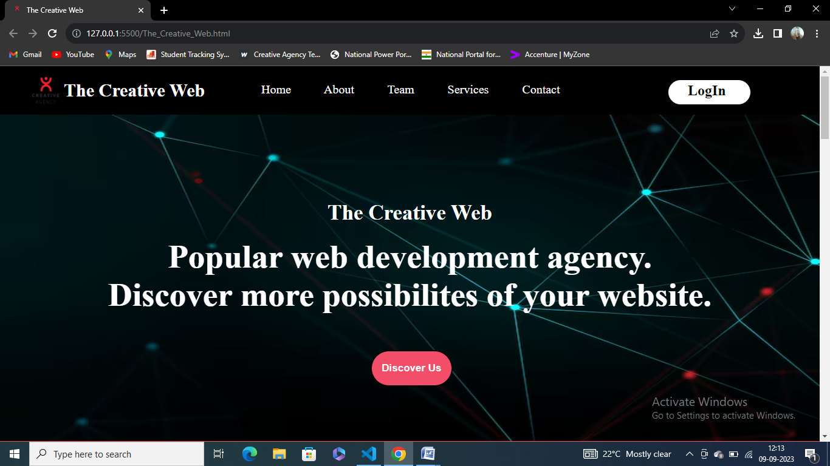

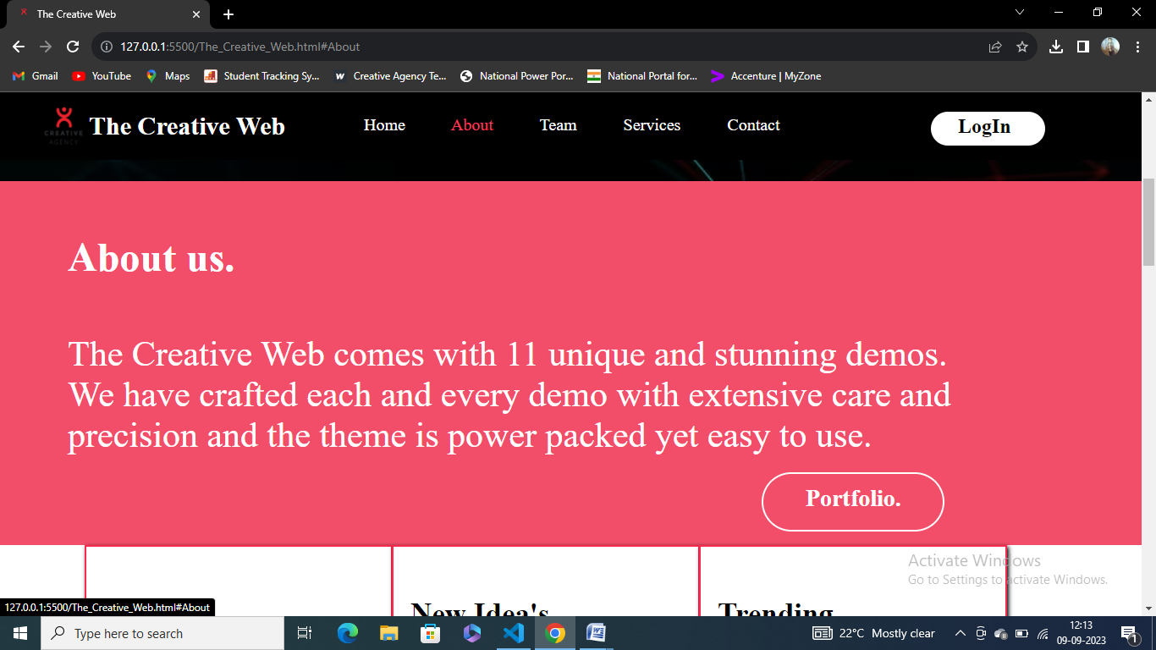

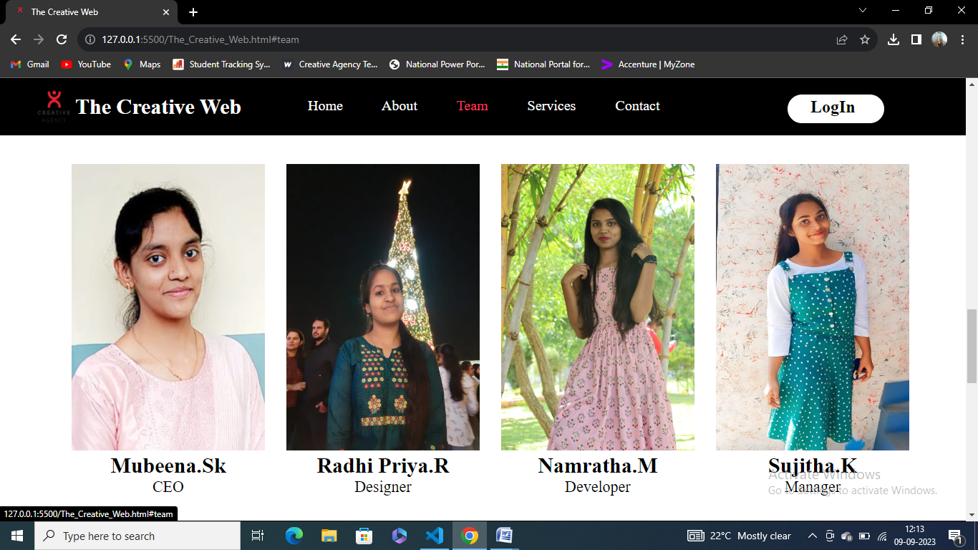

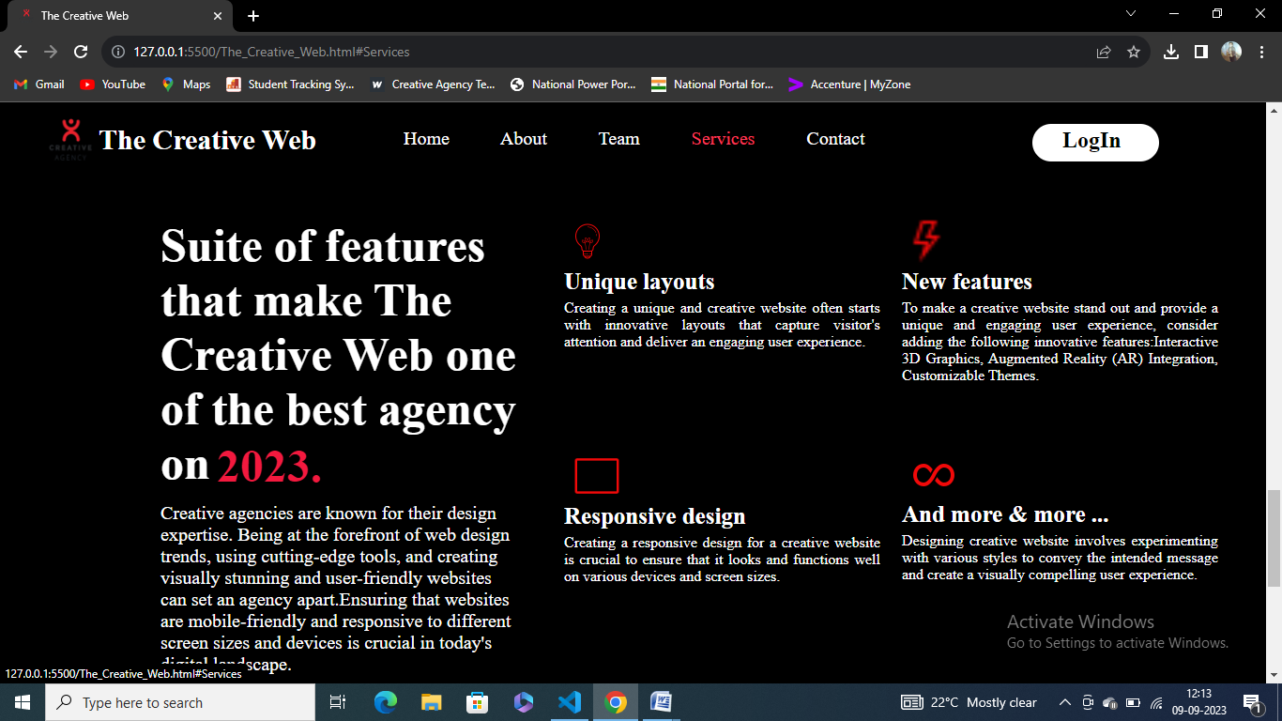

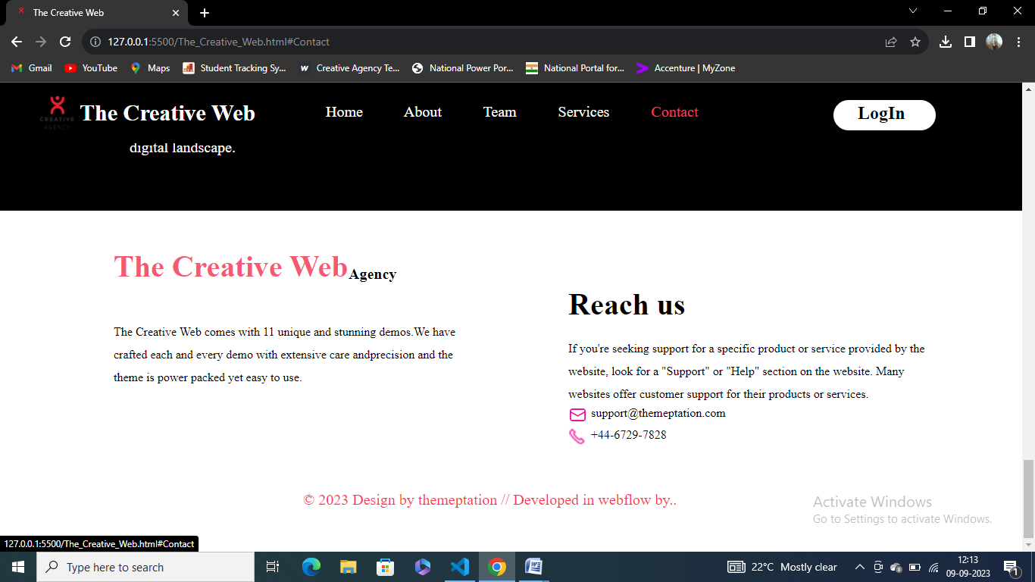

**Discover_us.html/css:**

<!DOCTYPE html>

<html lang="en">

<head>

    <meta charset="UTF-8">

    <meta name="viewport" content="width=device-width, initial-scale=1.0">

    <title>The Creative Web</title>

    <link rel="icon" href="marketing2.jpg.png">

    <style>

        *{

            margin: 0px;

            box-sizing: border-box;

        }

        #h2{

            color: white;

        }

        #h2:hover{

            color: rgb(252, 59, 91);

        }

        #nav1{

            text-decoration: none;

            color: white;

        }

        #nav1:hover{

            color: rgb(252, 59, 91);

        }

        #b1{

            color: white;

            font-size: 17px;

        }

        #but1{

            height: 60px;

            background-color: rgb(243, 78, 105);

            border: 2px solid black;

            margin-left: 610px;

            margin-top: 60px;

            width: 10%;

            border-radius: 30px;

        }

        #but1:hover{

            background-color: rgb(245, 10, 49);

        }

</style>

<body>

    <div style="width: 100%;height: 80px;background-color: black;position: sticky;top: 0px;">

       <img src="marketing2.jpg.png" style="width: 50px;height: 50px;margin-top: 15px;margin-left: 50px;">

        <h2 style="font-size: 30px;min-height: 65px;line-height: 65px;margin-left: 105px;margin-top: -62px;"><b id="h2">The Creative Web</b></h2>

        <a name="Home"></a>

        <nav style="margin-left: 430px;font-size: 20px;margin-top: -45px;word-spacing: 50px;" >

            <a href="The_Creative_Web.html#Home" id="nav1">Home</a>

            <a href="The_Creative_Web.html#About" id="nav1">About</a>

            <a href="The_Creative_Web.html#team" id="nav1">Team</a>

            <a href="The_Creative_Web.html#Services" id="nav1">Services</a>

            <a href="The_Creative_Web.html#Contact" id="nav1">Contact</a>

        </nav>

        <div style="height: 40px;width: 10%;border: solid 2px white;margin-left: 1100px;margin-top: -27px;background-color: white;border-radius: 20px;"><h2 style="min-height: 30px;line-height: 30px;margin-left: 30px;"><a href="LoginCreative.html" style="color: black;text-decoration: none;">LogIn</a></h2></div>

    </div>

    <div style="width: 100%;height: 538px;">

        <img src="background.jpg" width="100%" height="538px">

        <h2 align="center" style="margin-top: -400px;font-size: 35px;color: white;">The Creative Web</h2>

        <h1 align="center" style="font-size: 55px;color: white;margin-top: 20px;">Popular web development agency. <br> Discover more possibilites of your website.</h1>

        <button id="but1"><a href="Discover_us.html" style="text-decoration: none;"><b id="b1">Discover Us</b></a></button>

    </div>

    <div style="height: 600px;width: 100%;border: 20px solid rgb(247, 91, 117);">

        <h2 align="center" style="padding: 50px;">Benifits of choosing <b style="color: rgb(250, 79, 108);font-size: 30px;">The Creative Web</b> Designing company</h2>

        <ul>

            <li style="font-size: 18px;"><b>Unique and Memorable Designs: </b>Creative web design companies specialize in crafting unique and eye-catching website designs that help your brand stand out from competitors. Their creative approach ensures that your website makes a strong first impression.</li><br>

            <li style="font-size: 18px;"><b>Brand Consistency: </b>Creative web designers understand the importance of maintaining brand consistency. They ensure that your website's design aligns with your brand's visual identity, logo, and messaging, reinforcing your brand image.</li><br>

            <li style="font-size: 18px;"><b>User Engagement: </b>Creative designs can enhance user engagement. An aesthetically pleasing and user-friendly website encourages visitors to explore your content, spend more time on your site, and potentially convert into customers or clients.</li><br>

            <li style="font-size: 18px;"><b>Effective Storytelling:</b>Creative designers excel at storytelling through visuals and graphics. They can visually communicate your brand's story, values, and mission, making it easier for visitors to connect with your message.</li><br>

            <li style="font-size: 18px;"><b>Improved Conversion Rates:</b>Creative web design isn't just about aesthetics; it also focuses on optimizing user experience and user interface (UI/UX). Well-designed websites are more likely to convert visitors into customers, subscribers, or leads.</li><br>

            <li style="font-size: 18px;"><b>Mobile Responsiveness: </b> web designers prioritize mobile responsiveness, ensuring that your website looks and functions beautifully on various devices, including smartphones and tablets, which is critical in today's mobile-driven world.</li><br>

            <li style="font-size: 18px;"><b>Visual Hierarchy: </b> understand how to establish a clear visual hierarchy, guiding visitors to the most important content and calls to action. This enhances the user's journey through your website.</li><br>

        </ul>

    </div>

</div>

</body>

</html>

**Screenshots:**

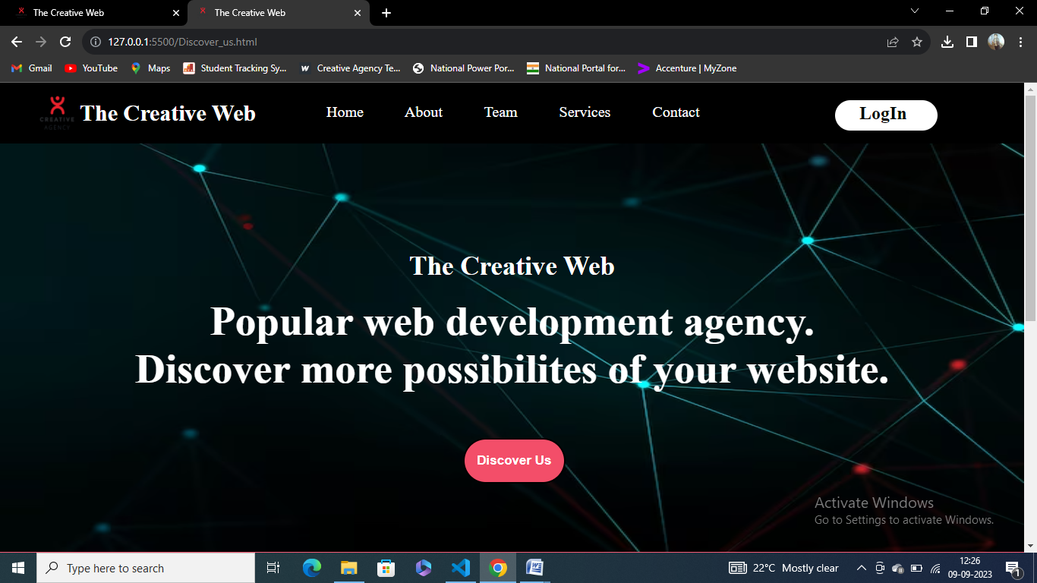

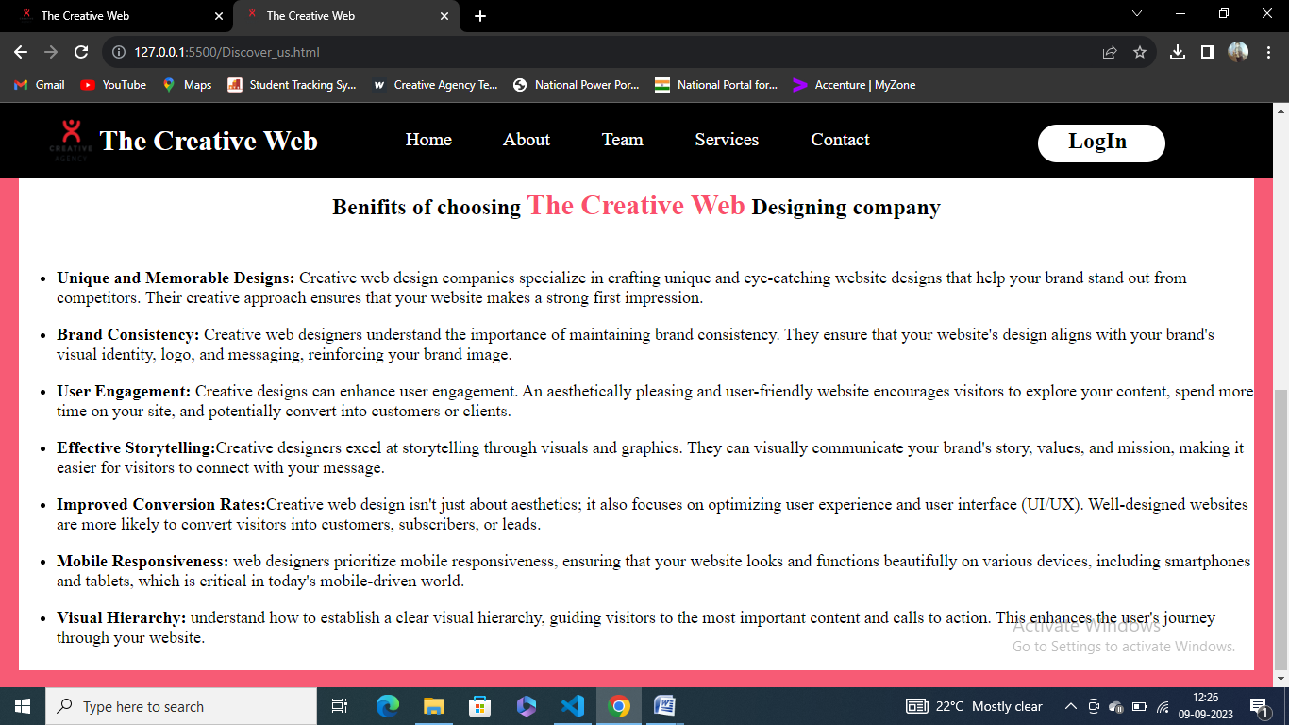

**Portfolio.html/css:**

<!DOCTYPE html>

<html lang="en">

<head>

    <meta charset="UTF-8">

    <meta name="viewport" content="width=device-width, initial-scale=1.0">

    <title>The Creative Web</title>

    <link rel="icon" href="marketing2.jpg.png">

    <style>

        *{

            margin: 0px;

            box-sizing: border-box;

        }

        #nav1{

            text-decoration: none;

            color: white;

        }

        #nav1:hover{

            color: rgb(252, 59, 91);

        }

        #h2{

            color: white;

        }

        #h2:hover{

            color: rgb(252, 59, 91);

        }

        #b1{

            color: white;

            font-size: 17px;

        }

        #but1{

            height: 60px;

            background-color: rgb(243, 78, 105);

            border: 2px solid black;

            margin-left: 610px;

            margin-top: 60px;

            width: 10%;

            border-radius: 30px;

        }

        #but1:hover{

            background-color: rgb(245, 10, 49);

        }

    </style>

</head>

<body>

        <div style="width: 100%;height: 80px;background-color: black;position: sticky;top: 0px;">

           <img src="marketing2.jpg.png" style="width: 50px;height: 50px;margin-top: 15px;margin-left: 50px;">

            <h2 style="font-size: 30px;min-height: 65px;line-height: 65px;margin-left: 105px;margin-top: -62px;"><b id="h2">The Creative Web</b></h2>

            <a name="Home"></a>

            <nav style="margin-left: 430px;font-size: 20px;margin-top: -45px;word-spacing: 50px;" >

                <a href="The_Creative_Web.html#Home" id="nav1">Home</a>

                <a href="The_Creative_Web.html#About" id="nav1">About</a>

                <a href="The_Creative_Web.html#team" id="nav1">Team</a>

                <a href="The_Creative_Web.html#Services" id="nav1">Services</a>

                <a href="The_Creative_Web.html#Contact" id="nav1">Contact</a>

            </nav>

            <div style="height: 40px;width: 10%;border: solid 2px white;margin-left: 1100px;margin-top: -27px;background-color: white;border-radius: 20px;"><h2 style="min-height: 30px;line-height: 30px;margin-left: 30px;"><a href="LoginCreative.html" style="color: black;text-decoration: none;">LogIn</a></h2></div>

        </div>

        <div style="width: 100%;height: 538px;">

            <img src="background.jpg" width="100%" height="538px">

            <h2 align="center" style="margin-top: -400px;font-size: 35px;color: white;">The Creative Web</h2>

            <h1 align="center" style="font-size: 55px;color: white;margin-top: 20px;">Popular web development agency. <br> Discover more possibilites of your website.</h1>

            <button id="but1"><a href="Discover_us.html" style="text-decoration: none;"><b id="b1">Discover Us</b></a></button>

        </div>

        <div style="width: 100%;height: 600px;">

            <a name="team"></a>

            <h2 style="font-size: 45px;min-height: 120px;line-height: 120px;margin-left: 80px;">Our Team</h2>

            <a href="Mubeena_Resume.html" style="color: black;text-decoration: none;" target="_blank"><div style="width: 20%;height: 400px;margin-left: 100px;">

                <img src="M_photo.jpg.jpg" style="width: 100%;height: 400px;">

                <p style="font-size: 30px;" align="center"><b>Mubeena.Sk</b></p>

                <p style="font-size: 22px;" align="center">CEO</p>

             </div></a>

            <a href="radhi_resume.html" style="color: black;text-decoration: none;" target="_blank"><div style="width: 20%;height: 400px;margin-left: 400px;margin-top: -400px;">

                <img src="radhi.jpg.jpeg" style="width: 100%;height: 400px;">

                <p style="font-size: 30px;" align="center"><b>Radhi Priya.R</b></p>

               <p style="font-size: 22px;" align="center">Designer</p>

            </div></a>

           <a href="nammu_resume.html" style="color: black;text-decoration: none;" target="_blank"> <div style="width: 20%;height: 400px;margin-left: 700px;margin-top: -400px;">

            <img src="nammu.jpg.jpeg" style="width: 100%;height: 400px;">

            <p style="font-size: 30px;" align="center"><b>Namratha.M</b></p>

           <p style="font-size: 22px;" align="center">Developer</p>

        </div></a>

            <a href="sujitha_resume.html" style="color: black;text-decoration: none;" target="_blank"><div style="width: 20%;height: 400px;margin-left: 1000px;margin-top: -400px;">

                <img src="Sujitha.jpg.jpeg" style="width: 100%;height: 400px;">

                <p style="font-size: 30px;" align="center"><b>Sujitha.K</b></p>

               <p style="font-size: 22px;" align="center">Manager</p>

            </div></a>

        </div><br>

</body>

</html>

**Screenshots:**

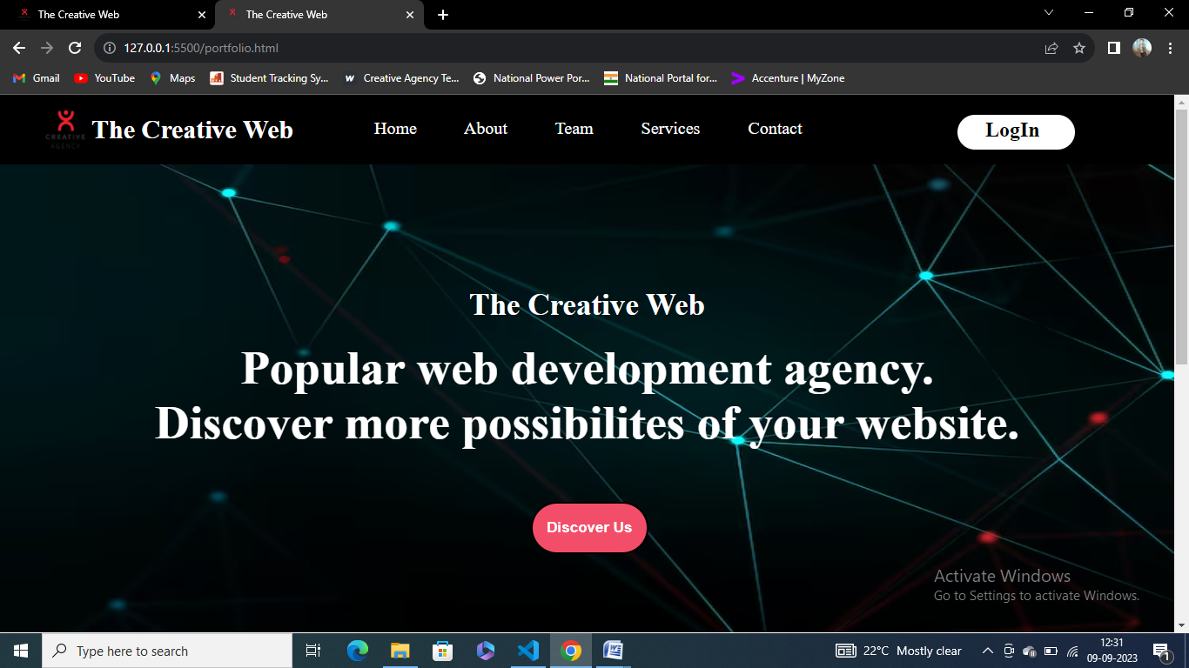

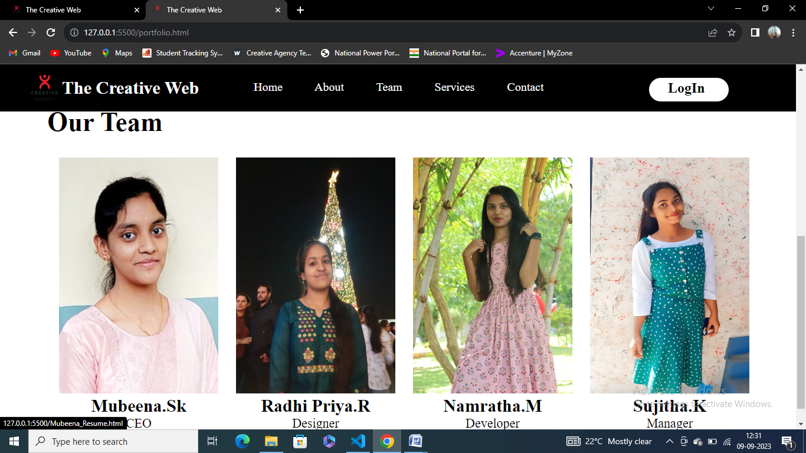

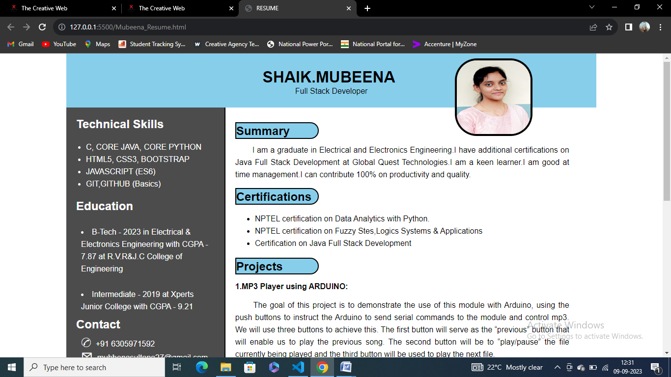

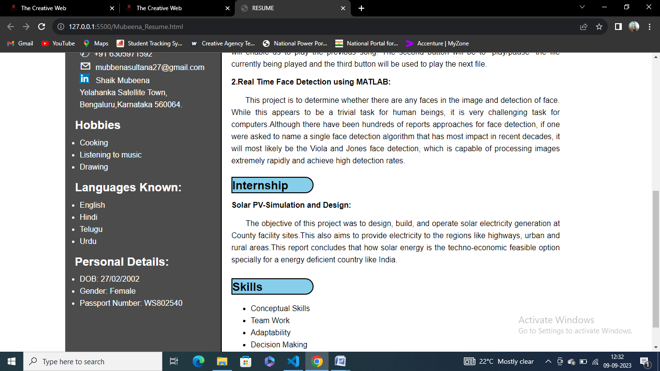

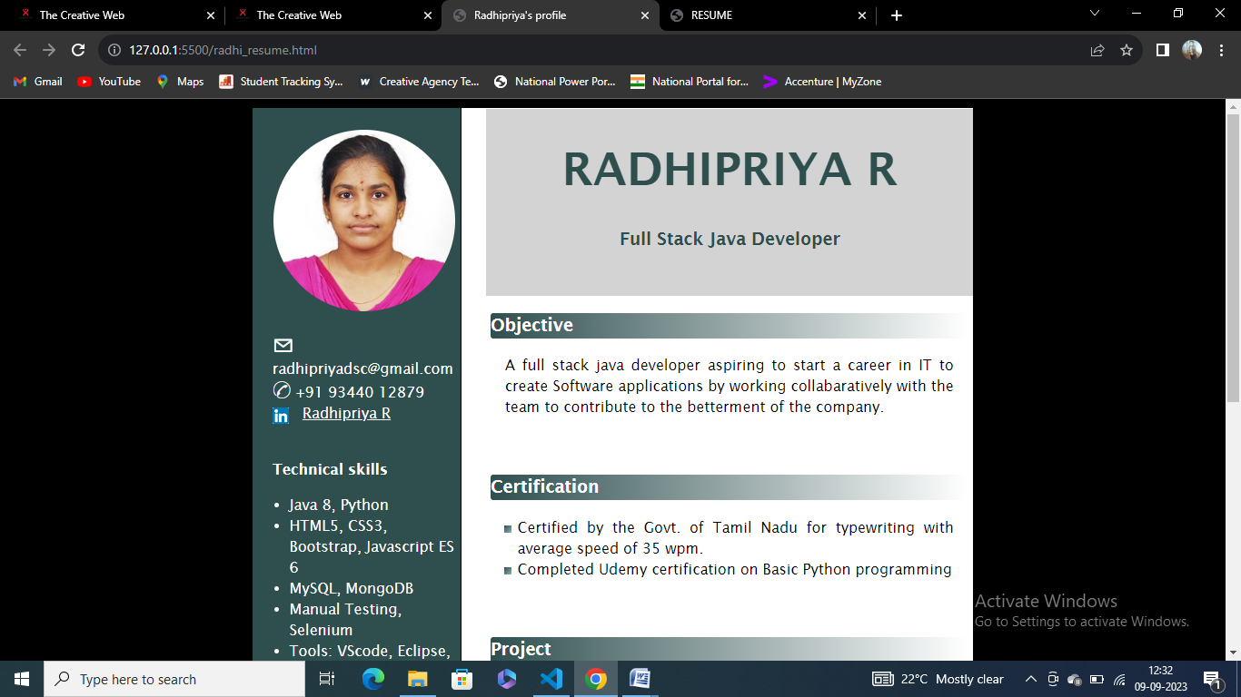

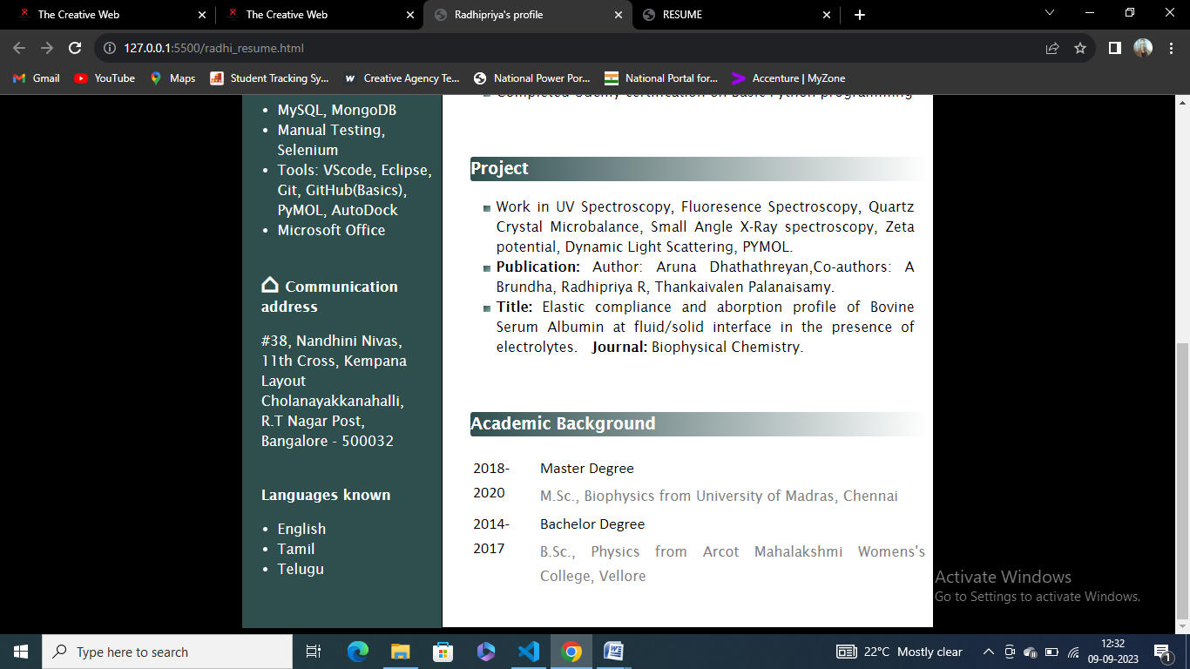

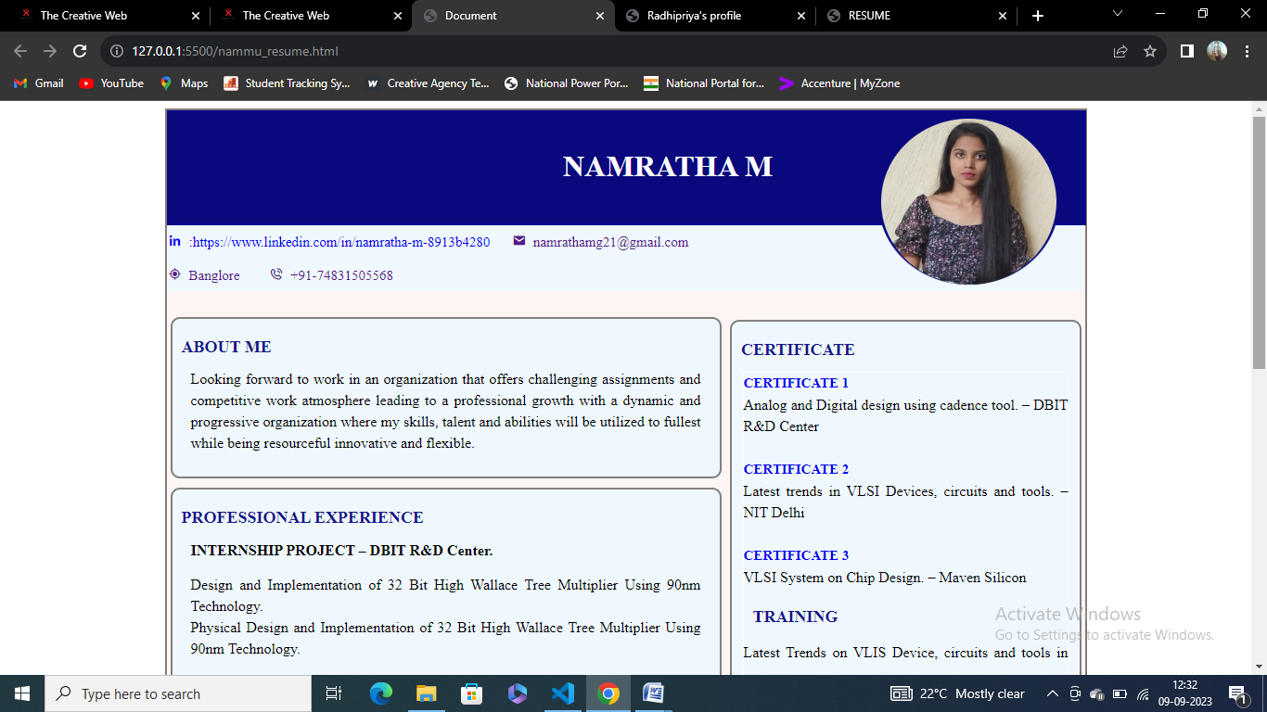

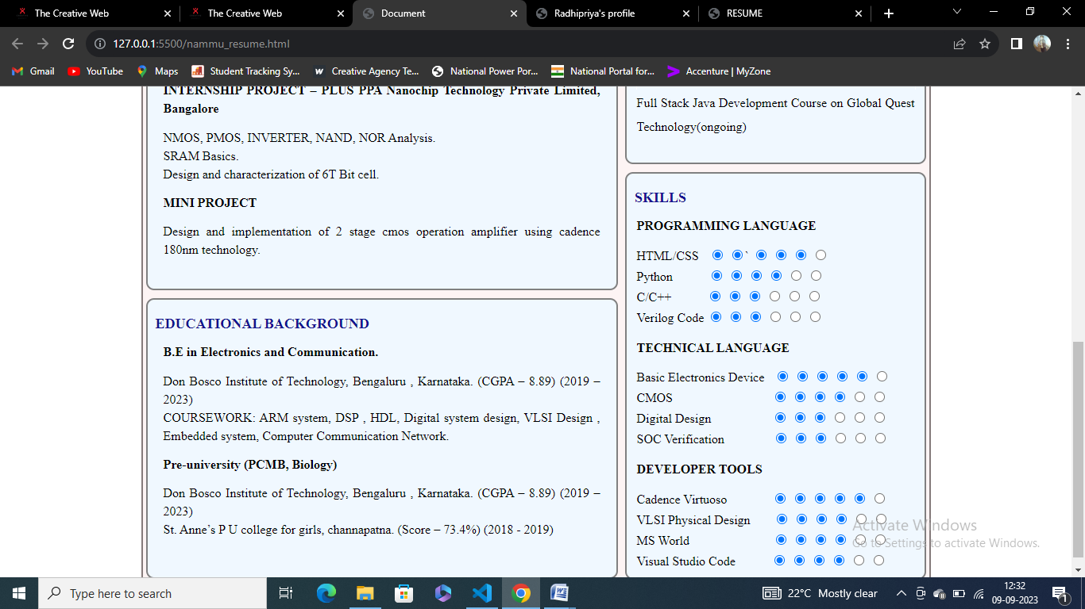

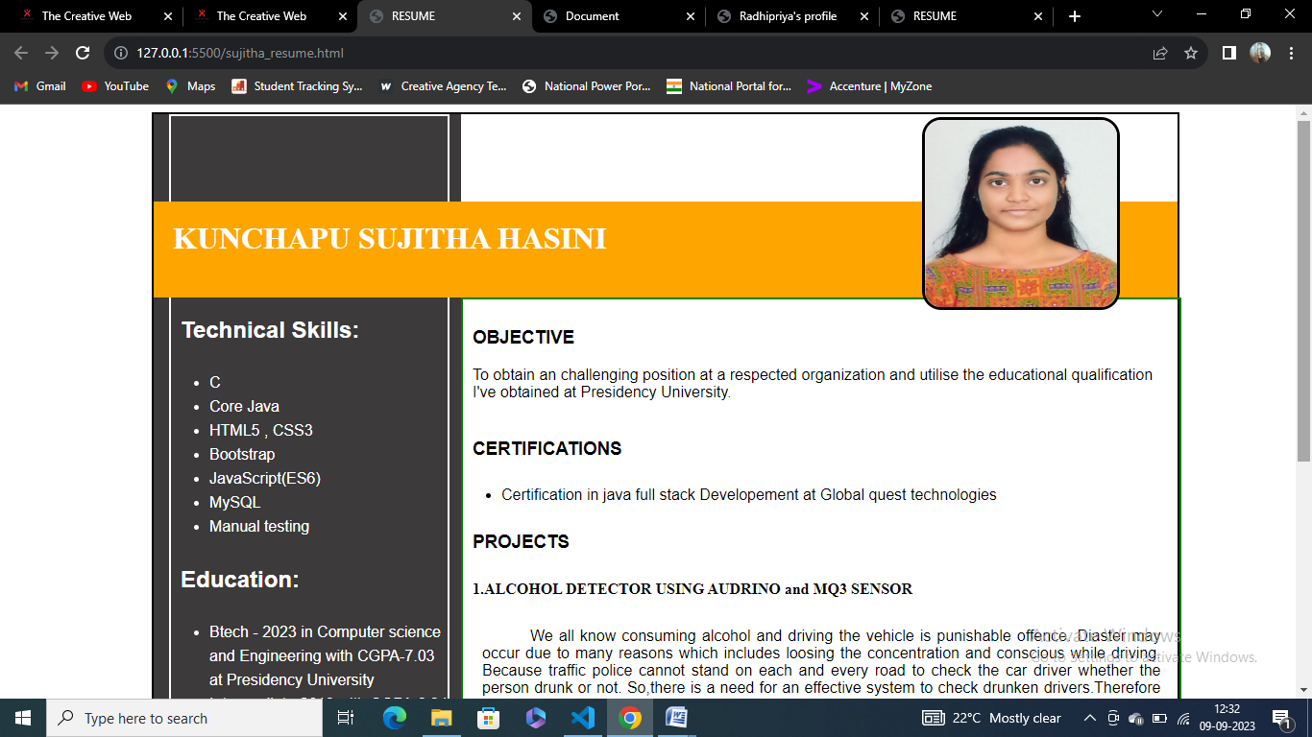

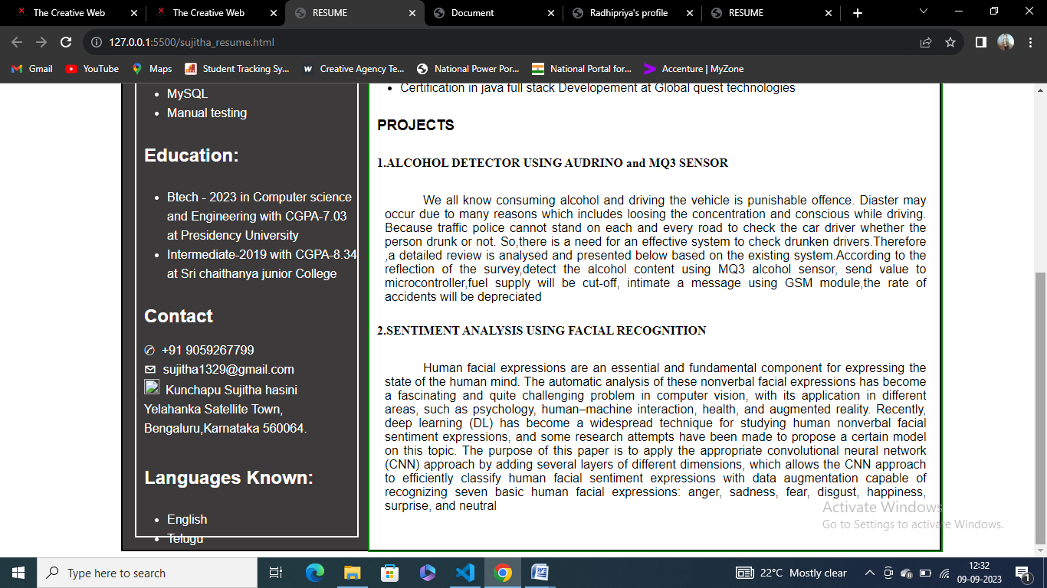

**Click_here.html/css:**

<!DOCTYPE html>

<html lang="en">

<head>

    <meta charset="UTF-8">

    <meta name="viewport" content="width=device-width, initial-scale=1.0">

    <title>Click_here</title>

    <style>

        *{

            margin: 0px;

            box-sizing: border-box;

        }

        #h2{

            color: white;

        }

        #h2:hover{

            color: rgb(252, 59, 91);

        }

        #nav1{

            text-decoration: none;

            color: white;

        }

        #nav1:hover{

            color: rgb(252, 59, 91);

        }

    </style>

</head>

<body>

    <div style="width: 100%;height: 80px;background-color: black;position: sticky;top: 0px;">

        <img src="marketing2.jpg.png" style="width: 50px;height: 50px;margin-top: 15px;margin-left: 50px;">

         <h2 style="font-size: 30px;min-height: 65px;line-height: 65px;margin-left: 105px;margin-top: -62px;"><b id="h2">The Creative Web</b></h2>

         <a name="Home"></a>

         <nav style="margin-left: 430px;font-size: 20px;margin-top: -45px;word-spacing: 50px;" >

             <a href="The_Creative_Web.html#Home" id="nav1">Home</a>

             <a href="The_Creative_Web.html#About" id="nav1">About</a>

             <a href="The_Creative_Web.html#team" id="nav1">Team</a>

             <a href="The_Creative_Web.html#Services" id="nav1">Services</a>

             <a href="The_Creative_Web.html#Contact" id="nav1">Contact</a>

         </nav>

         <div style="height: 40px;width: 10%;border: solid 2px white;margin-left: 1100px;margin-top: -27px;background-color: white;border-radius: 20px;"><h2 style="min-height: 30px;line-height: 30px;margin-left: 30px;"><a href="LoginCreative.html" style="color: black;text-decoration: none;">LogIn</a></h2></div>

     </div>

    <div style="height: 1300px;width: 100%;">

        <div style="height: 80px;width: 100%;">

            <h1 style="min-height: 72px;line-height: 72px;margin-left: 330px;color: rgb(247, 38, 73);">Innovative solutions to boost your creative projects.</h1>

        </div>

        <div style="height: 1250px;width: 100%;">

           <p  style="font-size: 20px;padding: 20px;color: rgb(247, 38, 73);"> 1. **Collaborative Brainstorming Sessions:**</p>

           <p style="margin-left: 50px;font-size: 18px;padding: 20px;text-indent: 40px;">Organize brainstorming sessions with diverse teams, including people from different backgrounds, industries, or expertise areas. This can lead to unique perspectives and ideas that you might not have considered otherwise.</p>

            <p  style="font-size: 20px;padding: 20px;color: rgb(247, 38, 73);">2. **Cross-Disciplinary Collaboration:**</p>

            <p style="margin-left: 50px;font-size: 18px;padding: 20px;text-indent: 40px;"> Collaborate with professionals from unrelated fields to gain fresh insights and inspiration. For example, a web designer could partner with a biologist to create a unique science-themed website.</p>

            <p  style="font-size: 20px;padding: 20px;color: rgb(247, 38, 73);">3. **Mind Mapping and Visual Thinking:**</p>

            <p style="margin-left: 50px;font-size: 18px;padding: 20px;text-indent: 40px;"> Use mind mapping and visual thinking techniques to generate ideas and map out project concepts. Tools like Miro and MindMeister can help facilitate this process.</p>

            <p  style="font-size: 20px;padding: 20px;color: rgb(247, 38, 73);">4. **Crowdsourcing and Crowdfunding:**</p>

            <p style="margin-left: 50px;font-size: 18px;padding: 20px;text-indent: 40px;">Leverage crowdfunding platforms to gather financial support for your creative projects. Crowdsourcing ideas or designs from a global audience can also bring innovative solutions.</p>

            <p  style="font-size: 20px;padding: 20px;color: rgb(247, 38, 73);">5. **Virtual Reality (VR) and Augmented Reality (AR):**</p>

            <p style="margin-left: 50px;font-size: 18px;padding: 20px;text-indent: 40px;">Incorporate VR or AR elements into your creative projects to provide immersive experiences. These technologies can enhance storytelling, product design, and marketing campaigns.</p>

           <p  style="font-size: 20px;padding: 20px;color: rgb(247, 38, 73);"> 6. **AI-Driven Creativity:**</p>

            <p style="margin-left: 50px;font-size: 18px;padding: 20px;text-indent: 40px;">Explore how artificial intelligence can assist in generating creative content, such as writing, art, or music. AI tools can help automate repetitive tasks, allowing you to focus on higher-level creativity.</p>

            <p  style="font-size: 20px;padding: 20px;color: rgb(247, 38, 73);">7. **Hackathons and Creative Challenges:**</p>

            <p style="margin-left: 50px;font-size: 18px;padding: 20px;text-indent: 40px;">Host hackathons or creative challenges within your team or community to encourage innovative thinking and problem-solving. Offer prizes or recognition to incentivize participation.</p>

            <p  style="font-size: 20px;padding: 20px;color: rgb(247, 38, 73);">8. **Storytelling Workshops:**</p>

            <p style="margin-left: 50px;font-size: 18px;padding: 20px;text-indent: 40px;">Attend storytelling workshops to hone your narrative skills. Effective storytelling can captivate your audience and convey the essence of your creative projects more powerfully.</p>

            <p  style="font-size: 20px;padding: 20px;color: rgb(247, 38, 73);">9. **Sustainability and Eco-Friendly Practices:**</p>

            <p style="margin-left: 50px;font-size: 18px;padding: 20px;text-indent: 40px;">Embrace sustainable and eco-friendly practices in your creative projects. Explore materials, techniques, and technologies that reduce environmental impact.</p>

            <p  style="font-size: 20px;padding: 20px;color: rgb(247, 38, 73);">10. **Blockchain for Intellectual Property Protection:**</p>

            <p style="margin-left: 50px;font-size: 18px;padding: 20px;text-indent: 40px;">Utilize blockchain technology to protect intellectual property and ensure fair compensation for your creative work. Blockchain can provide transparency and traceability.</p>

            <p  style="font-size: 20px;padding: 20px;color: rgb(247, 38, 73);">11. **Virtual Studios and Remote Collaboration Tools:**</p>

            <p style="margin-left: 50px;font-size: 18px;padding: 20px;text-indent: 40px;">Take advantage of virtual studios and remote collaboration tools to work with team members and collaborators from around the world. This can broaden your creative network.</p>

            <p  style="font-size: 20px;padding: 20px;color: rgb(247, 38, 73);">12. **Open Source Collaboration:**</p>

            <p style="margin-left: 50px;font-size: 18px;padding: 20px;text-indent: 40px;">Engage in open-source projects and communities to collaborate with like-minded individuals and contribute to innovative solutions in your field.</p><br><br><br>

            <p style="margin-left: 50px;font-size: 18px;text-indent: 40px;margin-top: -25px;">Remember that innovation often involves taking calculated risks and stepping outside of your comfort zone. Be open to experimentation and be willing to adapt to new technologies and trends as they emerge. By continuously seeking out innovative solutions, you can keep your creative projects fresh and engaging.</p>

        </div>

    </div>

</body>

</html>

**Screenshots:**

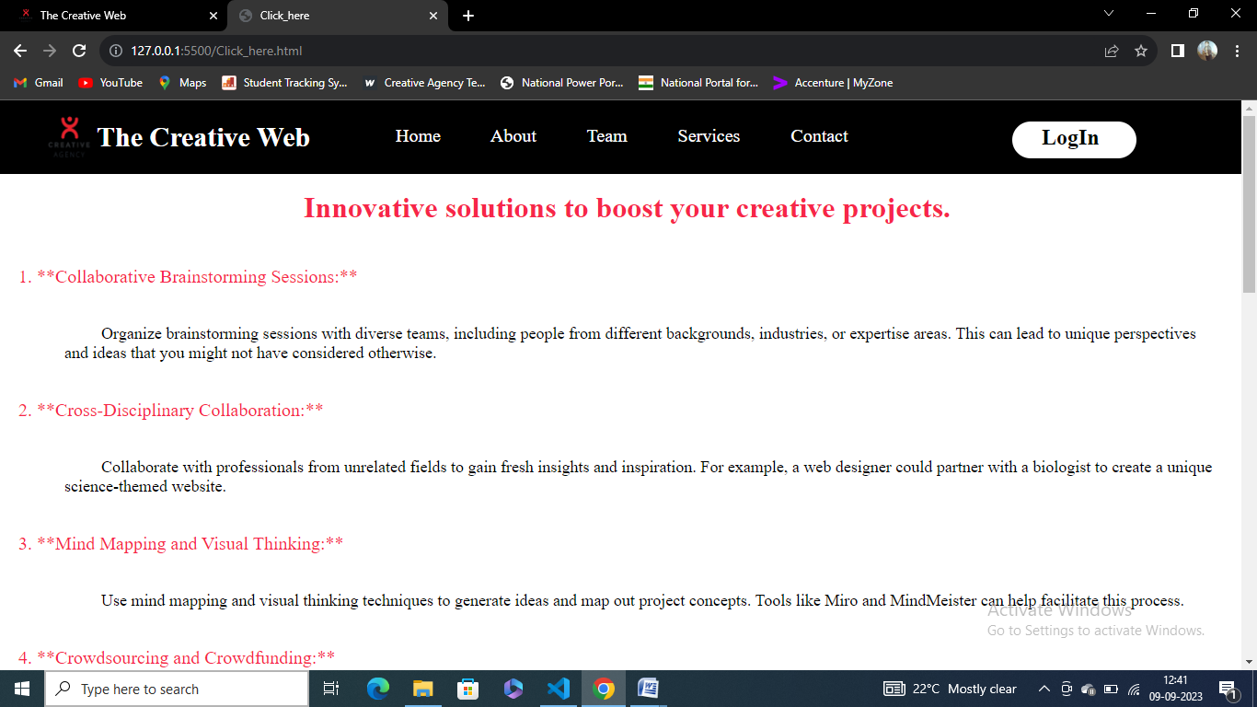

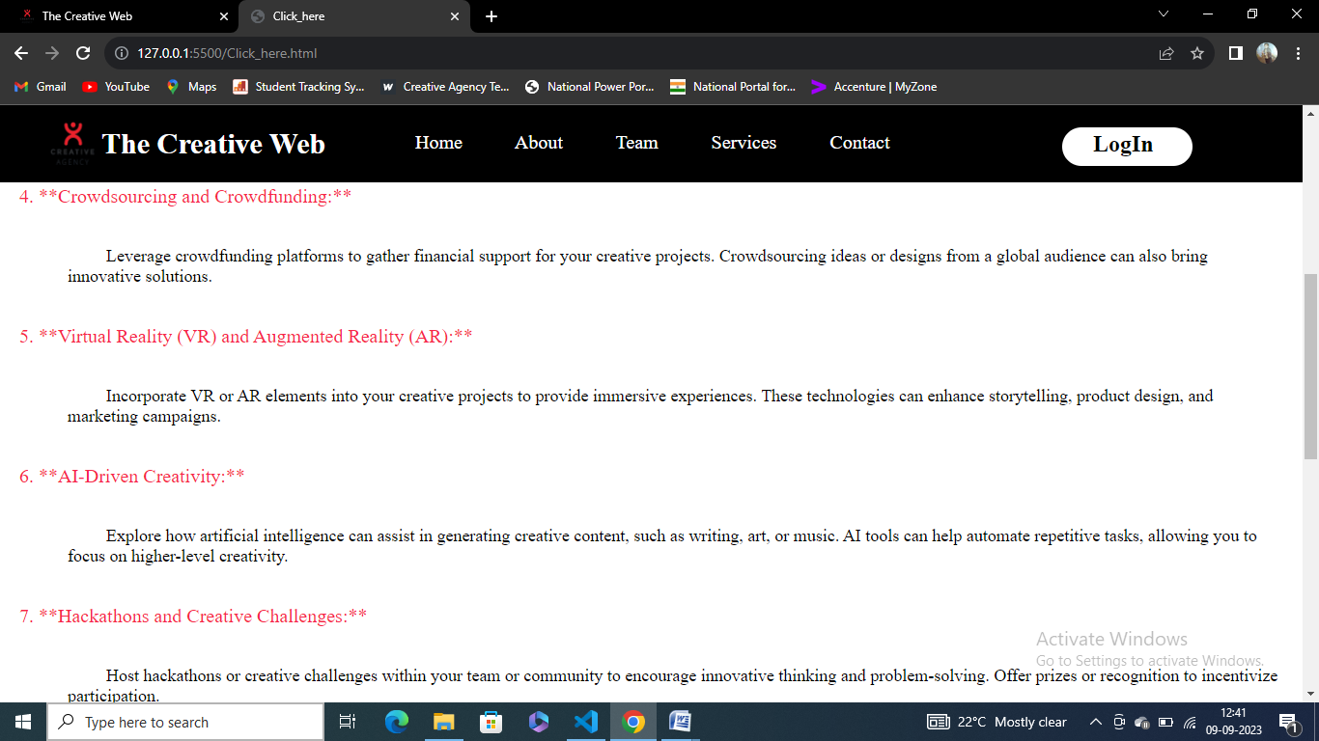

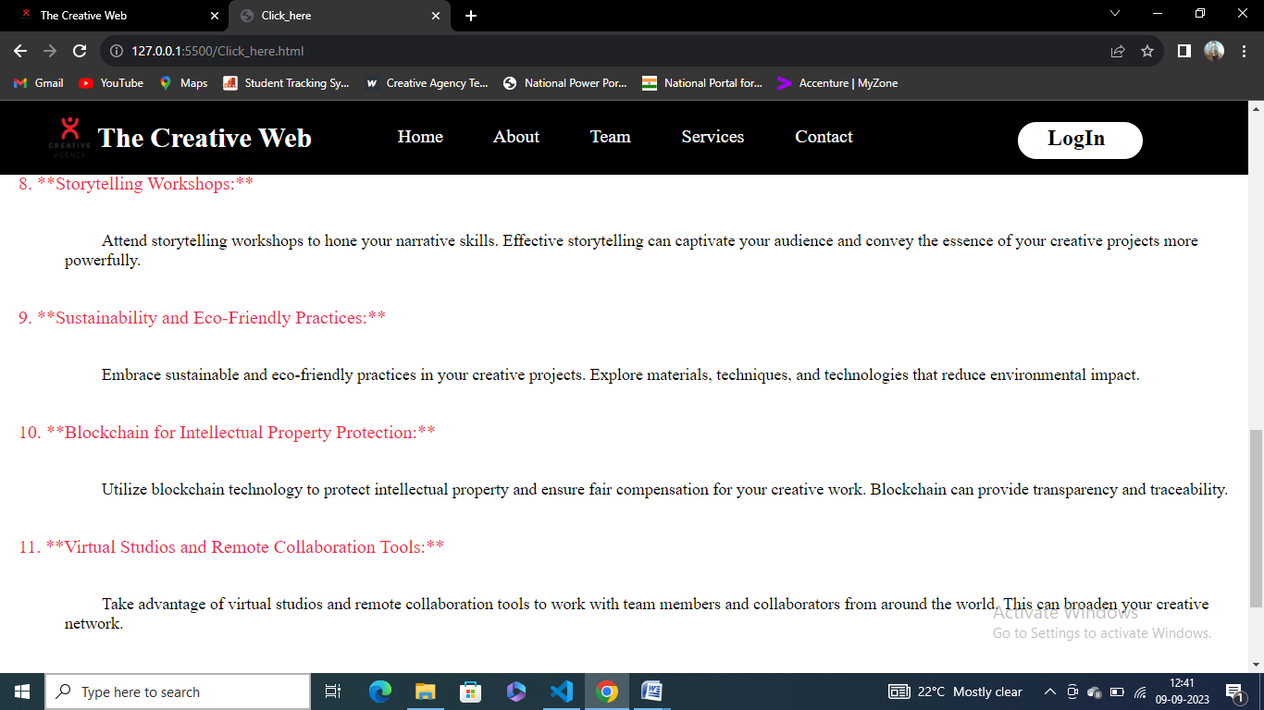

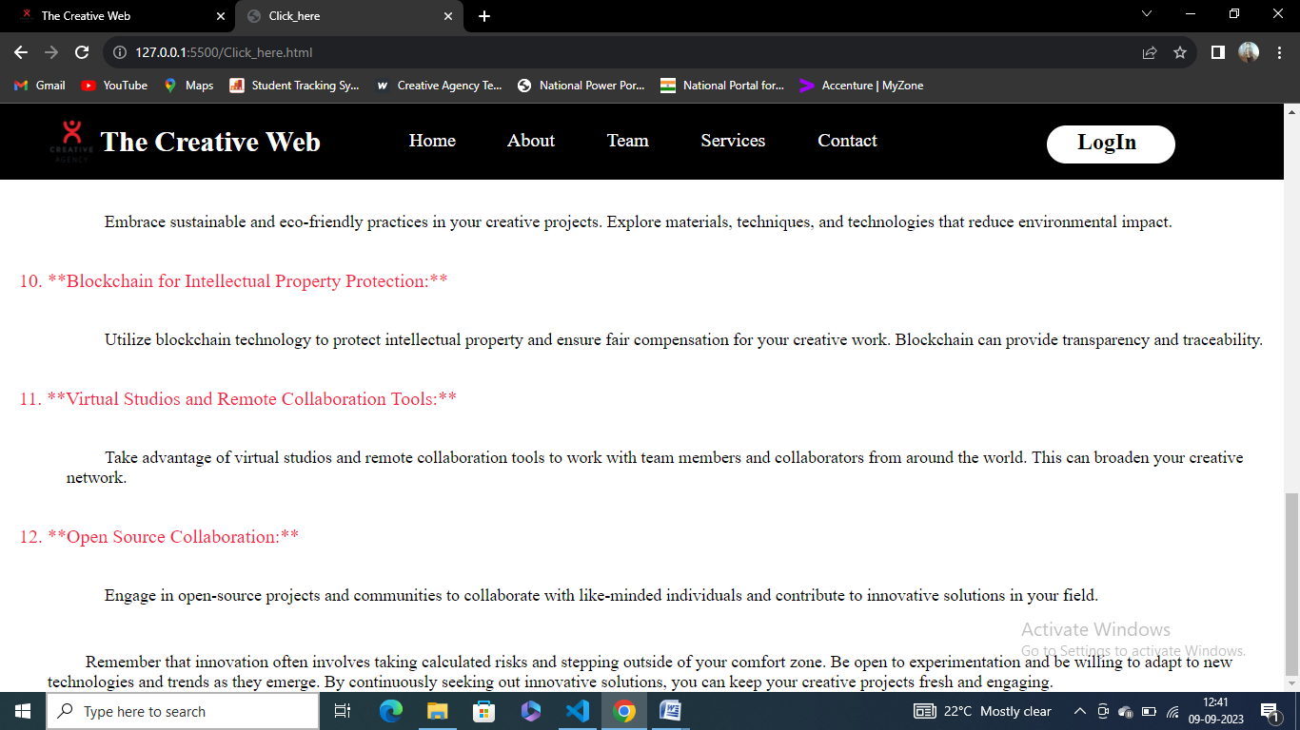

**LoginCreative.html/css:**

<!DOCTYPE html>

<html lang="en">

<head>

    <meta charset="UTF-8">

    <meta name="viewport" content="width=device-width, initial-scale=1.0">

    <title>LogIn</title>

    <style>

        *{

            margin: 0px;

            box-sizing: border-box;

        }

        #div1{

            background-repeat: no-repeat;

            background-size:cover ;

        }

    </style>

</head>

<body>

    <div style="height: 619px;width: 50%;border: 1px solid black;background-image: url('background.jpg');" id="div1"><h1 align="center" style="margin-top: 300px;font-size: 50px;color: white;">The Creative Web</h1></div>

    <div style="height: 618px;width: 49.9%;margin-left: 682px;margin-top: -619px;">

        <img src="marketing2.jpg.png" style="height: 100px;width: 100px;margin-left: 300px;margin-top: 100px;">

    </div>

    <div style="width: 30%;height: 300px;border: 1px solid black;margin-left: 830px;margin-top: -410px;background-color: whitesmoke;">

        <form action="The_Creative_Web.html">

            <label for="email" ><p style="margin-top: 20px;margin-left: 70px;">Username or Email Address</p></label>

            <input type="email" id="email" required style="margin-left: 70px;height: 30px;width: 60%;"><br><br>

            <label for="pass" style="margin-left: 70px;">Password</label><br>

            <input type="password" id="pass" required style="margin-left: 70px;height: 30px;width: 60%;"><br><br><br>

            <a href="" style="text-decoration: none;color: black;"><p style="margin-left: 50px;">Forgot Password?</p></a><br>

            <a href="signup.html" style="text-decoration: none;color: black;"><p style="margin-left: 50px;">Don't Have a Account?<b>SingUp</b></p></a>

            <button style="margin-left: 280px;height: 30px;background-color: skyblue;"><a href="" style="text-decoration: none;color: black;"><p style="font-size: 15px;">Login</p></a></button>

        </form>

    </div>

</body>

</html>

**Screenshots:**

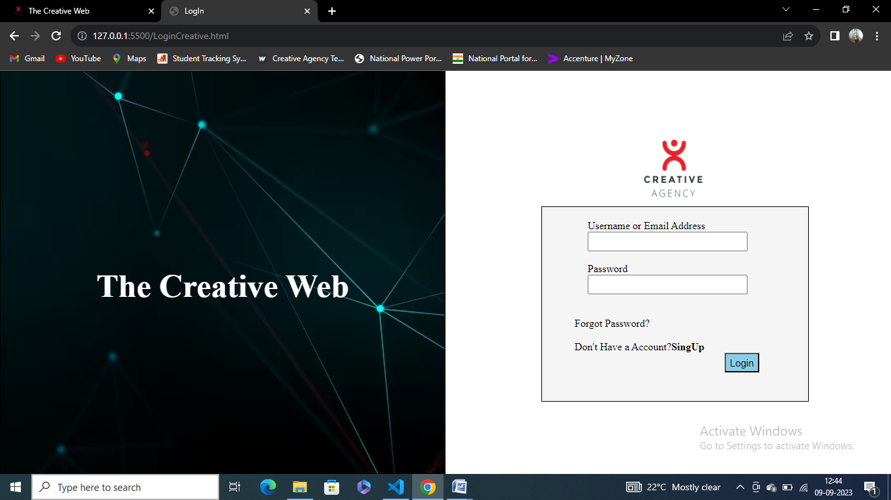

**Signup.html/css:**

<!DOCTYPE html>

<html lang="en">

<head>

    <meta charset="UTF-8">

    <meta name="viewport" content="width=device-width, initial-scale=1.0">

    <title>SingUp</title>

    <style>

        *{

            margin: 0px;

            box-sizing: border-box;

        }

        #div1{

            background-repeat: no-repeat;

            background-size:cover ;

        }

    </style>

</head>

<body>

    <div style="height: 619px;width: 50%;border: 1px solid black;background-image: url('background.jpg');" id="div1"><h1 align="center" style="margin-top: 300px;font-size: 50px;color: white;">The Creative Web</h1></div>

    <div style="height: 618px;width: 49.9%;margin-left: 682px;margin-top: -619px;">

        <img src="marketing2.jpg.png" style="height: 100px;width: 100px;margin-left: 300px;margin-top: 20px;">

    </div>

    <div style="width: 30%;height: 450px;border: 1px solid black;margin-left: 830px;margin-top: -500px;background-color: whitesmoke;">

        <form action="The_Creative_Web.html">

            <h2 align="center" style="padding: 20px;">Sign Up</h2>

            <label for="name" ><p style="margin-top: 20px;margin-left: 70px;">First Name</p></label>

            <input type="text" id="name" required style="margin-left: 70px;height: 30px;width: 60%;"><br><br>

            <label for="lname" style="margin-left: 70px;">Last Name</label><br>

            <input type="text" id="lname" required style="margin-left: 70px;height: 30px;width: 60%;">

            <label for="email"><p style="margin-top: 20px;margin-left: 70px;">Email</p></label>

            <input type="email" id="email" required style="margin-left: 70px;height: 30px;width: 60%;">

            <label for="pass"><p style="margin-top: 20px;margin-left: 70px;">Password</p></label>

            <input type="password" id="pass" required style="margin-left: 70px;height: 30px;width: 60%;">

            <p align="center">Already a member?<a href="LoginCreative.html" style="text-decoration: none;color: black;"><b>LogIn</b></a></p>

            <button style="margin-left: 160px;height: 30px;background-color: skyblue;margin-top: 30px;width: 20%;"><a href="" style="text-decoration: none;color: black;"><p style="font-size: 15px;"><b>SignUp</b></p></a></button>

        </form>

    </div>

</body>

</html>

**Screenshots:**

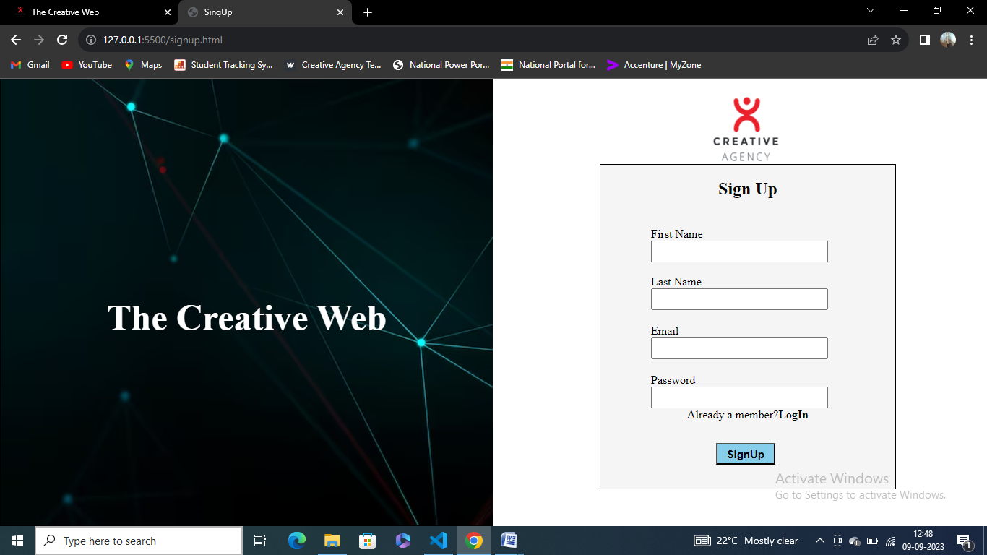

**CONCLUSION**

In conclusion, The Creative Web page represents the convergence of technology and artistry in the digital realm. It goes beyond the conventional boundaries of web design to deliver engaging and visually stunning online experiences. As we look at the evolving landscape of the internet, it's evident that creative web pages play a pivotal role in captivating audiences, telling stories, and leaving a lasting impression.

These web pages are not just a means of conveying information; they are a canvas for innovation, pushing the envelope of what's possible in design and interactivity. They are a reflection of a brand's personality, an artist's portfolio, or a platform for immersive storytelling. Creative web pages leverage the latest technologies, from responsive design and interactive elements to multimedia integration and stunning visuals, to create a holistic and engaging user experience.

In an age where digital presence is crucial, creative web pages are a testament to human ingenuity and our ability to harness technology to captivate, inspire, and connect with a global audience. They remind us that the internet is not merely a tool for communication but a dynamic space where creativity and innovation thrive.

As we continue to explore the vast possibilities of web design, the creative web page will undoubtedly remain a source of inspiration and a powerful medium for expressing ideas, sparking emotions, and pushing the boundaries of digital expression. Whether you're a web designer, developer, or simply a visitor, these pages invite you to embark on a journey where technology and artistry combine to redefine the digital landscape.